* Abstract classes cannot be instantiated directly. They may or may not contain abstract methods. A subclass inheriting an abstract class must provide implementations for all abstract methods unless it is also declared abstract.
* A final method cannot be overridden in a subclass.
* A final variable can only be assigned once.
* A final class can’t have subclasses.
* A final variable can be assigned during declaration or in the constructor.
* If a method in a subclass has the same name but different parameters, it is method overloading, not method overriding. Method overriding requires the same name and parameters.
* There will be a compilation error: Type mismatch: cannot convert from Parent to Child. child is a parent

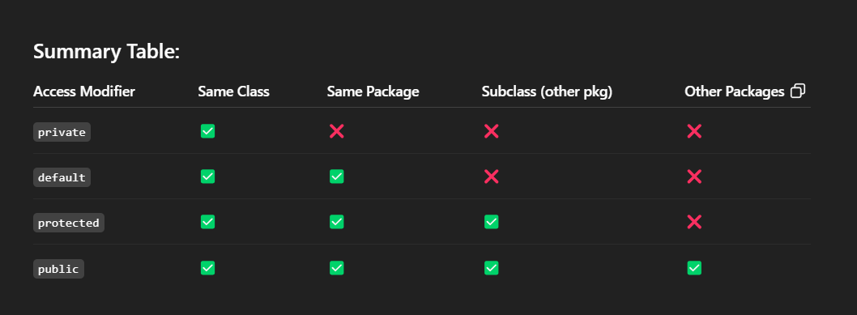

* `java.util` is a built-in Java package containing utility classes such as `ArrayList`, `HashMap`, and `Scanner`

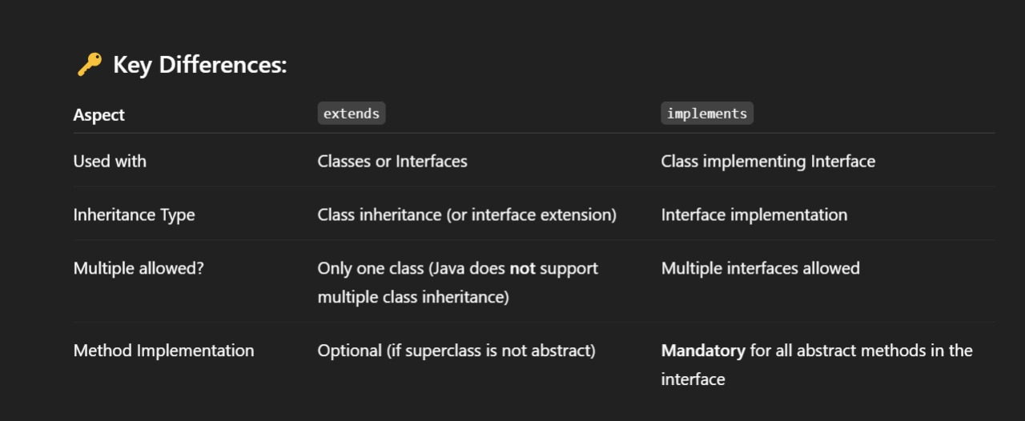

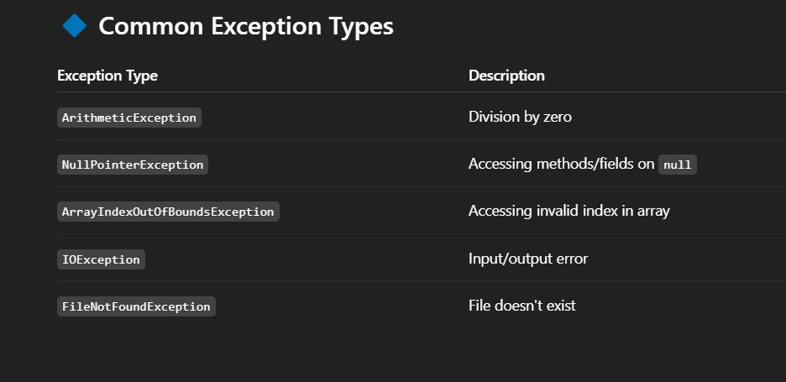

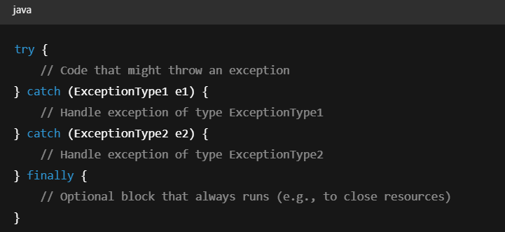

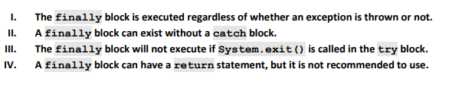

Variables in interfaces are public, static, and final by default. Hence, the value of x is accessible in the display method.

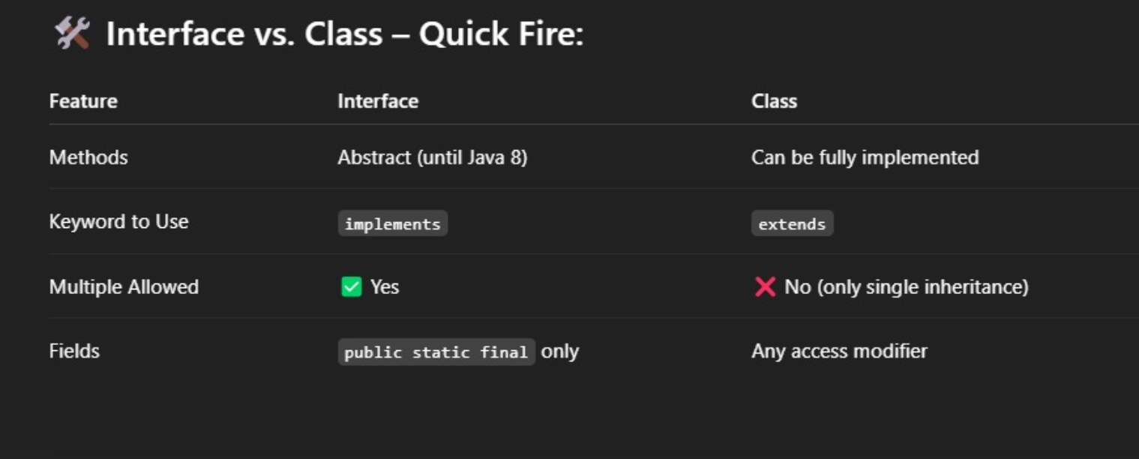

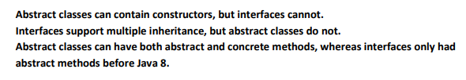

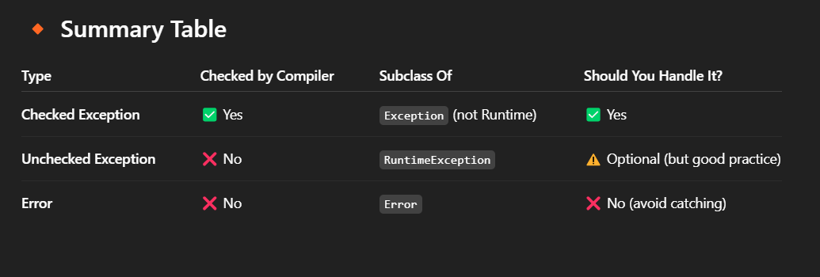

* Checked: IO, FileNotFoundException
* Unchecked: NullPointerException

ArithmeticException

ArrayIndexOutOfBoundsException

* ERROR: OutOfMemoryError

StackOverflowError

VirtualMachineError

* The throws keyword is used in a method signature to declare the exceptions that the method might throw, alerting callers to handle or propagate these exceptions.
* In Java, an interface can extend multiple interfaces. Interfaces can also contain public, static, and final variables, but they cannot be instantiated directly.
* you **cannot do**: new InterfaceName();
* You **must use**: a class that implements the interface

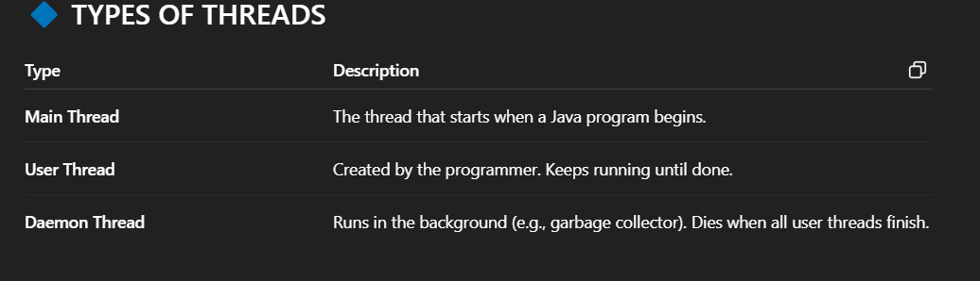

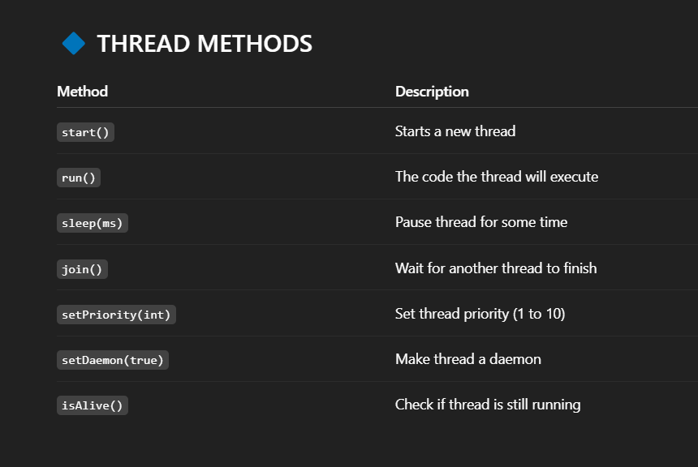

* Multithreading in Java allows multiple threads to run concurrently within the same program, sharing the same memory space. This feature makes Java programs more efficient, especially for tasks like multitasking or background processing. However, proper synchronization is crucial to avoid issues like data inconsistency. For a more detailed explanation of multithreading concepts, refer to the book Joy with Java.
* In Java, a thread can only be started once. If you try to call start() on the same thread object more than once, the JVM will throw an IllegalThreadStateException. This is because a thread's lifecycle allows it to transition to the "terminated" state after completing execution, and it cannot be restarted. For more details about the thread lifecycle

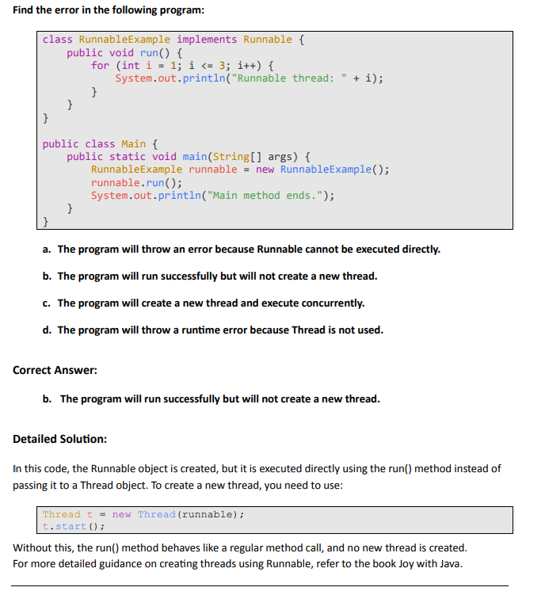

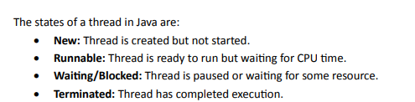

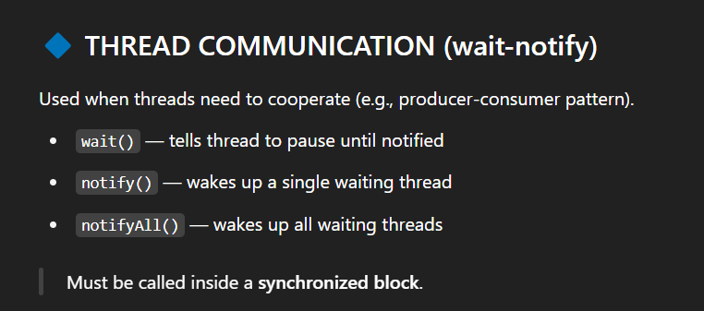

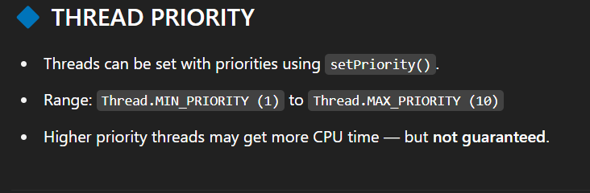

* When multiple threads access **shared resources**, use **synchronization** to avoid conflicts (e.g., two threads writing to the same variable).

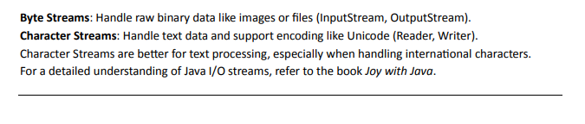

* Scanner-console-parse primitive types
* Buffered reader-input stream
* Data input stream-primitive data – binary format

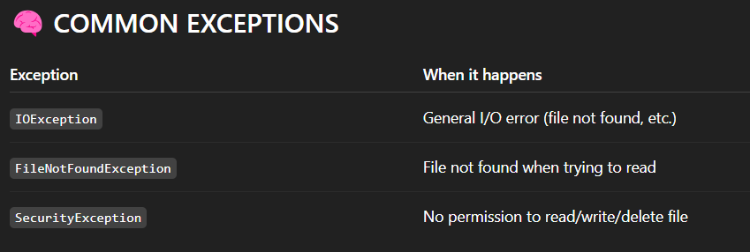

* The program writes the integer 100 to the file test.dat. Using the seek(0) method, the file pointer is reset to the beginning, and the integer is read back and printed.
* The exists() method in the File class checks if a file or directory exists in the specified path.
* "123".getBytes() converts the string into a byte array: [49, 50, 51] (ASCII of 1, 2, 3)
* obj.getChars(0, length, c, 0); 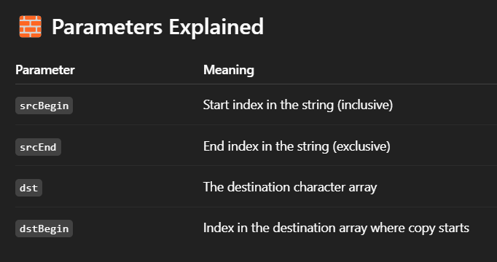
* this.num refers to instance variable
* PrintWriter.write(int) treats the int as a **character code**.
* Check box is used for multiple selection items whereas radio button is used for single selection answers to it.

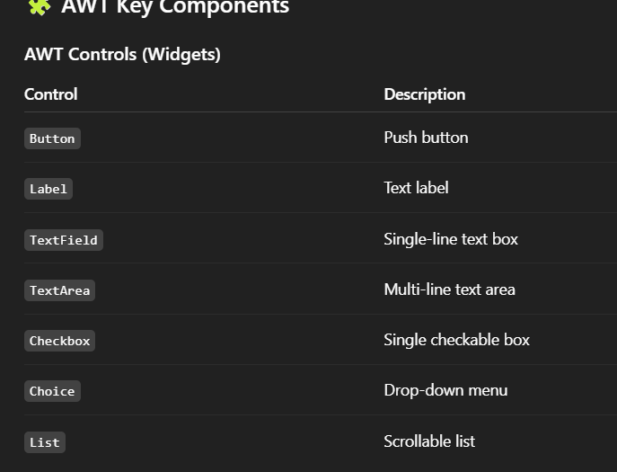

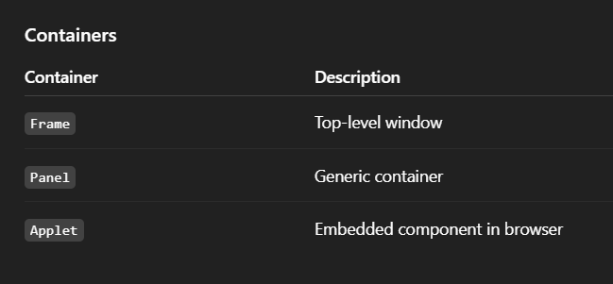

* JavaFX is a set of latest graphics and media packages in Java that enables developers to design, create, test, debug, and deploy rich client applications that operate consistently across diverse platforms.

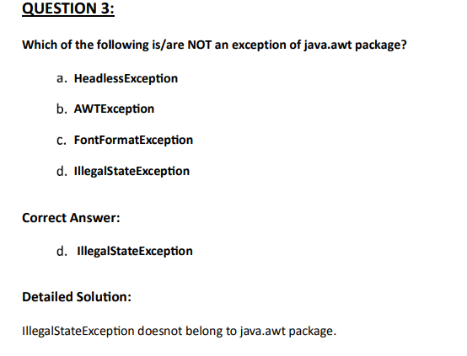

* The update() function does not update the component by checking an online repository rather it, sets the color of the graphics context to be the foreground color of this component, calls this component's paint method to completely redraw this component and clears this component by filling it with the background color.
* The function clear() in java.awt.list is used for remove all items from scrolling list.

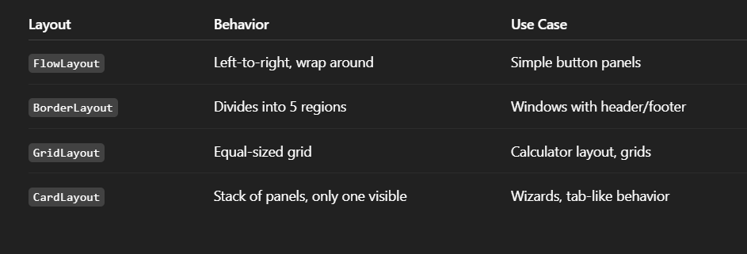

* BoxLayout lays out components in either a column or a row. You can specify extra space using an invisible component.
* AWT(Abstract Window Toolkit) is the Java library for creating GUI components like buttons and windows.

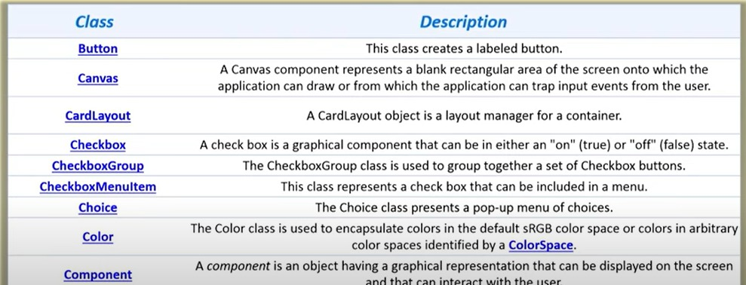

* A check box cannot be in both “on” and “off” state simultaneously. Further, several check boxes can be grouped together under the control of a single object, using the CheckboxGroup class. In a check box group, at most one button can be in the "on" state at any given time. Clicking on a check box to turn it on forces any other check box in the same group that is on into the "off" state
* JComboBox is a Swing component that provides a drop-down list from which users can select one option.

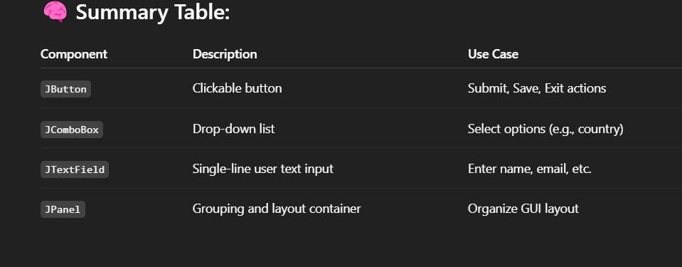

* JLabel can display both text and images/icons. It is commonly used for non-interactive purposes in Swing GUIs.
* The mouseClicked() method in the MouseListener interface is used to handle mouse click events in Java Swing.
* The add() method is used to add components like buttons, text fields, or panels to a JFrame.
* The setLayout() method is used to define the layout manager for a panel. FlowLayout is the default layout for JPanel.

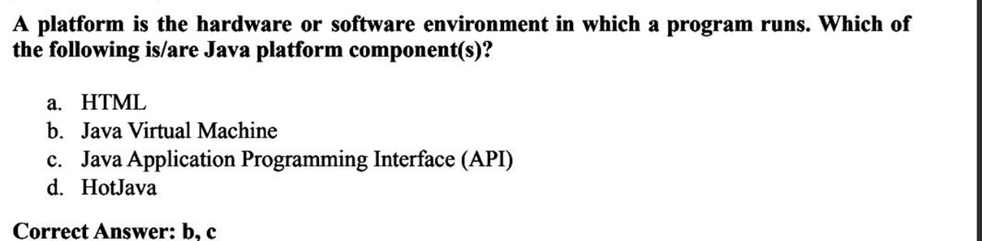

* A toggle button allows users to switch between two states, such as "on" or "off." It behaves like a checkbox, but it is represented as a button.
* In Java, the isUp() method is used to check whether a network interface is up and running. This method is part of the NetworkInterface class from the java.net package.
* In Java, Socket and ServerSocket are the primary components used for establishing client-server communication. These classes belong to the java.net package and are fundamental to networking in Java. String, Integer, JFrame, JButton, Scanner, and System are not used for basic networking functionality
* <https://nptel.ac.in> Resource name is nptel.ac.in. The protocol used is https and hence provides a secure connection to the website. The link is complete in all aspects and hence can open a website (if hosted). The ac.in portion of the website is top-level domain part and not a path.
* TCP, UDP are transport layer protocols. ARP is a Network - IP layer protocol. SMTP is Application layer protocol.
* The URL class provides methods to work with Uniform Resource Locators.
* ServerSocket is used to listen for incoming connections on a specific port, enabling communication with clients in server-client applications.
* JDBC stands for Java Database Connectivity, a Java API used to connect and interact with relational databases. It provides methods to query and update data in a database.
* DriverManager.getConnection("jdbc:mysql://localhost:3306/mydb", "user", "password")--The DriverManager.getConnection method establishes a connection to the specified database URL with the provided username and password.
* ResultSet rs = stmt.executeQuery("SELECT * FROM users"); ---The executeQuery method is used to execute SQL queries that return a ResultSet.
* The prepareStatement method prepares the SQL query for execution, allowing the use of parameterized inputs
* The executeUpdate method is used for SQL operations that modify data (INSERT, UPDATE, DELETE). It cannot be used for SELECT queries, which return a ResultSet.
* The DriverManager class loads the JDBC drivers and establishes connections to databases.
* To establish a connection to a database using JDBC, you use the DriverManager.getConnection() method. This method takes a JDBC URL, username, and password as parameters and returns a Connection object, which represents a connection to the database. The JDBC URL specifies the database type, location, and other connection details.
* java.sql package in Java contains the classes and interfaces for JDBC
* In Java, a thread can be created either by extending the Thread class or by implementing the Runnable interface.
* The start() method is used to begin execution of a new thread.
* FlowLayout arranges components in a row, in the order they are added.
* The setSize(width, height) method sets the size of the JFrame,(WH)
* The ResultSet object contains all records from the table, including those with null values.
* In Java, an array is declared using int[] arr = new int[5]; where 5 is the size.
* Swing is a lightweight GUI framework compared to AWT, which is heavyweight.